Baseball Analysis: Physical Attributes, Skill Metrics, and Performance
For the baseball component, we analyzed whether physical traits meaningfully predict Major League Baseball performance or whether skill-based metrics provide stronger explanatory value. The central question was whether larger or more athletic players produce better outcomes, and whether those relationships persist at both the individual and team levels. To address this, we integrated player-level physical, athletic, and performance data from multiple public sources. Statcast was used for sprint speed and batted-ball metrics, the MLB Stats API was used for player metadata and team records, and FanGraphs was used for performance indicators such as WAR, wRC+, strikeout rate, walk rate, and other batting statistics. This multi-source design allowed us to compare traditional physical variables, such as height and weight, against more baseball-specific skill variables, such as barrel rate and plate discipline.
At the player level, the analysis focused on position-normalized WAR as the primary performance outcome. Normalizing WAR by position helped control for differences in positional expectations, since offensive production, defensive value, and roster roles vary substantially across catchers, infielders, outfielders, and designated hitters. This adjustment made it possible to compare players across roles more fairly and reduced the risk of incorrectly attributing positional differences to physical traits. The baseline model included height, weight, sprint speed, average exit velocity, and barrel rate. The expanded model added skill and plate discipline variables, including strikeout rate, walk rate, and hard-hit percentage. Ridge regression was selected because several predictors are correlated, particularly contact-quality measures, and the regularization penalty helps reduce overfitting while preserving interpretability.
The model results show a clear difference between physical traits and skill-based performance indicators. The baseline model achieved a test R² of 0.255 with a test RMSE of 0.873, indicating that physical and athletic variables alone explained only a limited portion of player performance. After adding skill-based metrics, the expanded ridge model improved to a test R² of 0.480 and a test RMSE of 0.730. This improvement indicates that contact quality and plate discipline substantially increase predictive power. The strongest predictors in the expanded model were barrel rate, strikeout rate, sprint speed, and walk rate. Barrel rate had a strong positive coefficient, while strikeout rate had a strong negative coefficient, which is consistent with baseball intuition: players who generate high-quality contact and avoid excessive strikeouts tend to create more value. Walk rate also contributed positively, reflecting the importance of plate discipline and on-base skill.
In contrast, height and weight had minimal predictive value once baseball-specific skills were included. Height had a small negative coefficient, and weight was effectively neutral. This does not mean physical traits are irrelevant to baseball, but rather that their value appears to operate indirectly through skill expression. For example, size may contribute to power potential, but the model suggests that realized performance is better captured by outcomes such as barrel rate and exit velocity than by body size itself. This distinction is important because it separates raw physical potential from measurable baseball production. A larger player is not automatically more valuable; the value comes from translating physical capacity into contact quality, plate discipline, speed, and role-specific execution.
We also conducted a temporal analysis to determine whether the physical profile of MLB players has changed over time. Using multi-season data from 2019 through 2024, we compared average player height and sprint speed. Average height remained essentially flat, declining slightly from approximately 72.48 inches in 2019 to 72.17 inches in 2024. In contrast, average sprint speed increased from 27.07 ft/sec to 27.30 ft/sec over the same period. This pattern suggests that MLB players are not meaningfully getting bigger, but they are becoming faster. The trend supports the broader player-level findings: modern performance gains appear to be associated more with athleticism, training, and skill development than with increases in physical size.
Finally, we validated the player-level findings using team-level aggregation. We calculated average team height, average team weight, average sprint speed, and total player value, then compared these measures against team win percentage using publicly available MLB team records. The resulting correlations were weak or negligible. Average team height had a modest negative correlation with win percentage, average team weight had a weak negative relationship, and average sprint speed was close to zero at the team level. This suggests that simply aggregating physical traits across a roster does not explain team success. While sprint speed may matter for individual players, team outcomes depend on a broader combination of factors, including roster construction, pitching, defense, strategy, situational performance, and distribution of skill across roles.
Overall, the baseball analysis supports the conclusion that physical traits set a baseline for athletic potential but do not independently explain performance. Across player-level modeling, time-series trends, and team-level validation, skill-based variables consistently provided stronger explanatory value than height or weight. The strongest evidence came from the expanded ridge model, where barrel rate, strikeout rate, sprint speed, and walk rate dominated feature importance. These results align with the broader theme of the project: size may matter in some contexts, but in baseball, measurable skill execution and athletic efficiency are more important drivers of success.

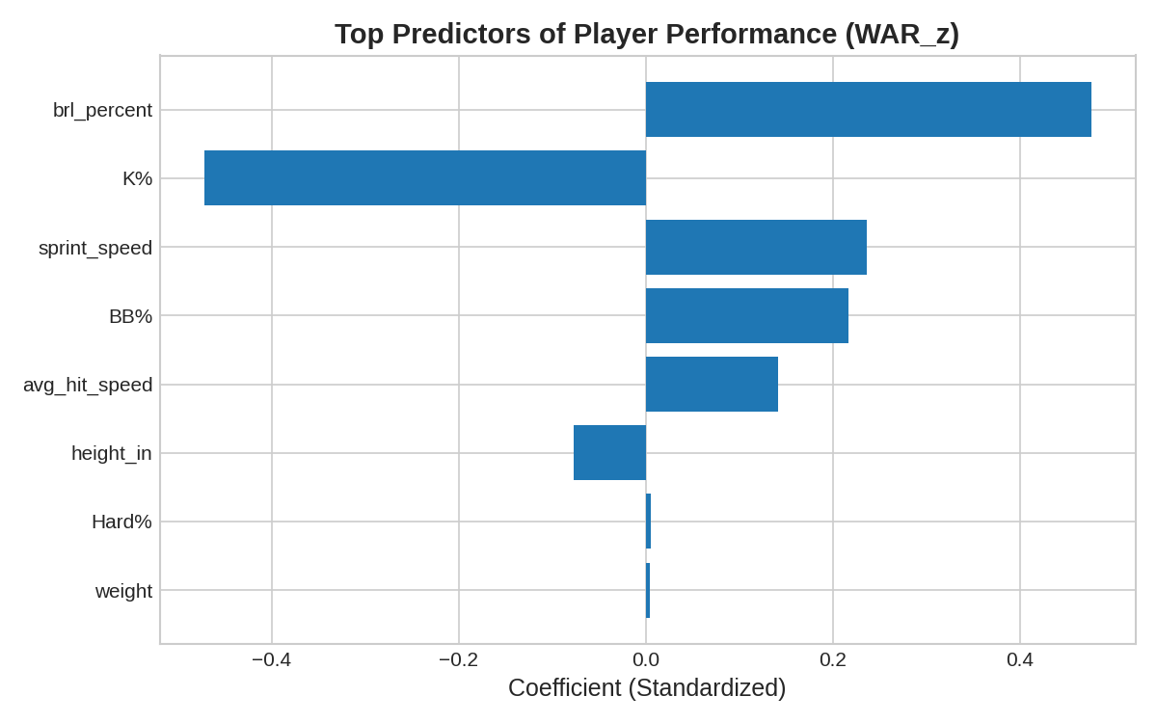
Figure 1: The expanded ridge model shows that barrel rate, strikeout rate, sprint speed, and walk rate are the strongest predictors of position-normalized WAR. Height and weight contribute little additional explanatory power once contact quality and plate discipline are included.

In baseball, size may create potential, but skill determines value.

